University of Toronto
Faculty of Applied Science and Engineering
Department of Mechanical and Industrial Engineering

Should the Toronto Raptors sign LeBron James?

Lucas Sciardi

MIE566
November 13, 2024

1 A brief background on LeBron James and the Toronto Raptors
Since joining the NBA in 2003, LeBron James has been one of the league’s most dominant players, playing for the Cavaliers, Heat, and Lakers. He has earned four MVP titles, 18 All-Star selections, and four championships, cementing his legacy as one of the greatest. Now in his age-39 season, LeBron continues to excel, averaging 25 points (13th in the league), 7.3 rebounds (32nd), and 8.3 assists (5th) last season, showing his sustained impact.
The Toronto Raptors, owned by Maple Leaf Sports & Entertainment (MLSE), joined the NBA in 1995 and won their first championship in 2019. Since then, however, the team has struggled, finishing 24th of 30 teams in 2023-24.
In this project, the Raptors’ management considers acquiring LeBron for the 2024-25 season. Assuming a trade is possible, an analyst is modeling potential profits if the team proceeds with this decision.
2 Problem statement and key decisions

LeBron James has revealed in an interview that he would love to play for the Raptors for a single season before retiring (a decision highly motivated by his love for Tim Hortons’ coffee). Despite being initially thrilled by this, Raptors management understands it would be costly to sign him, and the outcome of his season in Canada would depend on various decisions and events.

The Raptors have many goals, but for simplicity, we consider profit and winning the championship as their two main objectives. Note that this is a change from Part 1 where only profits were under consideration. Increased profits and chances of winning from a potential LeBron acquisition are subject to four major concerns:

- Would the Raptors’ fans be happy with LeBron playing for the team?
- What is the risk of him suffering an injury and not being able to play during the season?
- How much would the team’s performance improve with him on the team?
- Is the performance increase enough to win a championship?

Due to the sequential nature of decisions and outcomes and the continuous nature of the modeled variables, a bayesian network was built to represent the decision-making process. The key decision the Raptors have to make is whether to sign LeBron or not. Signing him would likely improve the team performance, while enhancing ticket and merchandise sales. However, the improvements in sales depend on how much Raptors fans like the player. Hence, the team has the opportunity of hiring a consulting firm to conduct market research to check if Raptor fans support the signing of LeBron.

Alternatively, the Raptors can request that betting companies investigate if LeBron is participating in illegal sports gambling. If he is caught doing so, there are serious consequences which would directly impact the Raptors organization. The Raptors only have the budget and time to pursue one of these information requests (market research or gambling investigation).

3 Uncertainty about popularity, injuries, and team performance

To model how decisions affect and are affected by the uncertainties, the analyst models them in the context of the questions provided by the DM and with data collected. A high-level summary of uncertainties is included in Table 1, with details for each outlined below it.

Table 1: Summary of uncertainties, 9 of which being subjective (based on the DM) and 3 being objective (based on data). See Figure 2 to observe the relationship between them in an influence diagram.

Uncertainty | Type | Brief Description
Popularity | Subjective | General interest level in LeBron James by people in Toronto.
Market Research Results | Subjective | Results provided by the consulting firm, measuring Popularity.
Games Played | Objective | Number of 2024-2025 regular season games played by LeBron.
Team Performance | Subjective | The level of play exhibited by the Raptors team during the 2024-2025 season, excluding LeBron James.
Games Won | Subjective | Number of games won by the Raptors during the 2024-2025 regular season. Influenced by uncertainties Games Played (By LeBron) and Team Performance.
Position In Standings | Objective | Whether the Raptors make the playoffs this season. Influenced by the number of Games Won.
Win Championship | Objective | The probability of the Raptors winning a championship based on their Position in Standings
Fill Rate | Subjective | Attendance rates from Raptors 2024-2025 regular season home games. Influenced by the following uncertainties: Popularity, Games Played, Games Won. This is used to determine Ticket Sales.
Merchandise Sales | Subjective | Sales made from Raptors jersey sales during the 2024-2025 season. Influenced by uncertainties Popularity and Games Played.
Gambling | Subjective | Probability that LeBron is participating in illegal NBA gambling.
Caught Gambling | Subjective | Probability of the NBA catching a player who is illegally gambling. Influenced by the Gambling uncertainty.
Gambling Investigation Result | Subjective | The result of a gambling data investigation to see if LeBron James has been illegally gambling.

Popularity. The first uncertainty expressed by management is LeBron's popularity with Raptors fans, measured as the proportion of Toronto’s population who are LeBron fans. An analyst surveyed 20 front-office staff, and most estimates lied within 0.6 to 0.7. Despite LeBron’s superstar status, his history of defeating the Raptors in the playoffs (2013-2018) may have reduced his fan base [1]. Based on this small sample, the analyst concluded that LeBron’s popularity follows a distribution of ~Beta(α = 5, β = 3). Popularity among Toronto fans is expected to directly impact ticket sales and jersey sales, affecting overall profit.

Market Research Results. As previously mentioned, there is the opportunity of conducting market research and better understanding how fans feel about him. After researching historical performance of top firms in the market, it is estimated that an expert consultant will say that the player is popular following a distribution of ~Bernoulli(p = Popularity). Even top firms are unable to give exact popularity figures, and their methods are only capable of indicating whether popularity is high (1) or low (0). The cost to do this research is discussed in Section 4.

Games Played. The number of games LeBron plays will increase the Raptors’ chances of winning. LeBron may miss games due to injuries, illness, or other personal reasons. Data was collected on LeBron’s games played over his 20-year career. This sample data was used to create a distribution for the number of games missed (GM) over an 82-game regular season [2]. This distribution is roughly modelled as GM = ~Gamma(α = 2, β = 5). Since the NBA season has 82 games, we model the number of games played as 82 - GM. A comparison of sample data along with the Gamma distribution is shown in Appendix A.

Team Performance. Irrespective of LeBron, the rest of the team’s performance will strongly impact their on-court success. It is assumed that the performance of the rest of the team is not influenced by LeBron. It is also assumed that the team will perform between 20% above or below their expected level, which is modeled as ~Uniform(0.8, 1.2). This was estimated after speaking directly with the head coach. He noted that the team’s performance is unpredictable, but confidently mentioned that that performance will not be beyond this range.

Games Won. The number of regular season games the Raptors win is influenced by the number of games LeBron plays (LGP), and the cumulative performance displayed by the rest of the Raptors team (TP). It is assumed that the level of LeBron’s performance stays consistent, game-by-game. LeBron is a much better player than anyone else on the Raptors roster, so his presence in games is highly impactful. The expected number of games won can be modelled by:$GW = 35TP + 0.14LGP$, where the baseline of 35 represents the number of games the Raptors won last year [3]. The 0.14 coefficient is LeBron’s uplift factor, representing his net impact on any given game’s outcome. This is based on a statistic called Wins Above Replacement (WAR), and is detailed in Appendix B.

Position in Standings. The Raptors’ position in the league standings depends on how many games they win. The Raptors play in the NBA’s Eastern Conference, which has 15 teams. From historical data, it is estimated that the position in standings follows a distribution of ~Poisson(𝜆) + 1 [4]. Lambda itself is a function of games won (GW): $λ= 312e^{-0.11GW}$. Details on how this formula was derived are shown in Appendix C.

Win Championship. If the Raptors finish anywhere in the top 8 of the standings, they qualify for the playoffs. From historical data, the odds of winning the championship based on position in standings were calculated, and can be seen in Table 2. If they miss the playoffs, they cannot compete for a championship.

Table 2: Probability of winning a championship based on position in standings [4]

Position in Standings | 1st | 2nd | 3rd | 4th, 5th, 6th | 7th, 8th
Probability of Winning Championship | 40% | 30% | 25% | 10% | 2%

Fill Rate (Ticket Sales): Raptors home game attendance depends heavily on LeBron's popularity, the number of games he plays in, and the number of games the Raptors win. This uncertainty focuses on the fill rate (FR) at Scotiabank Arena, where the Raptors play their home games. Only home game ticket sales are included in this model. The expected FR is calculated as the product of 0.7, F_{GW}, F_{LGP}, and F_{P}. The 0.7 coefficient is the baseline rate. F_{GW}, F_{LGP}, and F_{P} are scaling factors, and are functions of Games Won (GW), LeBron’s Games Played (LGP), and LeBron’s Popularity (P), respectively. Appendix D contains the equation derivation and formulas for all factors. After speaking with ticketing professionals at MLSE, they anticipate this variable to follow a Normal distribution with a 10% standard deviation. Thus, Ticket Sales ~ Normal(µ = FR, 𝜎 = 0.1 * FR).

Merchandise. Jersey sales make up the majority of all merchandise sales for the Toronto Raptors [5]. While merchandise includes a variety of products, this model will only consider jersey sales for simplicity. LeBron’s jersey sales will depend on his popularity and the number of games he plays in. After speaking with merchandise sales representatives from the Raptors, the analyst estimates that expected LeBron jersey sales (JS) can be modeled as:

$Expected LeBron Jersey Sales = JS= (\$133M)(0.5 + P)(0.2 + (\frac{LGP}{82})$) ,

where $133M represents baseline sales, P represents popularity and LGP is LeBron’s games played. Essentially, if LeBoron’s popularity is above 50%, jersey sales will increase from baseline. Also, LeBron must play in at least 80% of the games for jersey sales to increase from baseline. Further details on baseline merchandise sales can be found in Appendix E. The Raptors merchandise sales representatives believe that this figure is Normally distributed, with a standard deviation of 10%. Essentially, Merchandise Sales ~ Normal(µ = JS, 𝜎 = 0.1*JS).

Gambling Concerns. In recent years, the sports betting industry has seen rapid growth after Canada and the US legalized gambling [6]. However, the NBA is becoming increasingly concerned that many players are illegally betting on their own NBA games [7]. This season, the NBA has begun conducting operations to catch players doing this. After speaking with front-office executives and their contacts in the betting industry, it is estimated that any given player, including LeBron James, has a 60% likelihood of gambling, and has a 90% chance of being caught by the NBA. If a player is caught in a gambling scandal, all of his jerseys will immediately become unavailable for sale. It is assumed that players will be caught near the beginning of the season, resulting in 80% of forecasted annual merchandise sales being unrealized.

Gambling Investigation. As previously mentioned, the Raptors can decide to pay for major gambling sites to conduct a thorough investigation into their databases to check if LeBron James is gambling on his games. If he is in fact doing so, the investigation will flag it 90% of the time. If he is not, there is still a 1% false positive rate.

Once the distributions for popularity, the number of games played, and expected season performance were defined, the analyst was ready to estimate the uncertainties that directly impact revenues.

4 Revenues, costs, and profits

By analyzing the team’s previous income statement, the analyst models the revenue as the sum of ticket sales and merchandise sales. Similarly, costs are defined as the sum of costs independent of LeBron, the cost of his contract (if signed), and the cost of market research or gambling investigation (if conducted). This section goes over the details of the estimation of revenues and costs.

Signing LeBron. LeBron James’ contract is $52M USD per year. If the Raptors choose to trade for LeBron, they will incur this cost. In addition to LeBron’s contract, the Raptors have $155M USD in player salaries distributed across the rest of the team [8].

Market Research Consultants. The Raptors may decide to hire consultants to research LeBron James’ popularity within the Toronto market. Considering the current rates charged by top-tier consulting firms in Toronto, the Raptors estimate they will be quoted $1M USD [9].

Gambling Intelligence. Alternatively, the Raptors may request a thorough investigation into the databases of major betting sites. This is to conduct due diligence on whether LeBron is engaging in illegal gambling activities. Again, it is assumed that they will be quoted $1M USD [9].

Ticket Sales. It is assumed that ticket prices remain constant, at an average of $200 USD [10]. As shown in Section 3, the arena fill rate is Normally Distributed. There are 41 home games per season, and the Raptors home court (Scotiabank Arena) has a capacity of 20,000. Only regular season sales are considered in this model. Season ticket sales is modelled as:

$Ticket Sales = (Fill Rate)(\$200)(41)(20,000)$

Merchandise (Jersey) Sales. The NBA sells a variety of jersey types at different price points, depending on their level of authenticity. They all have differing volumes of sales, but using a weighted average approach, the average sale price per jersey sold is approximately $111 USD. Details on this calculation are shown in Appendix E. It is assumed that jersey prices remain constant irrespective of the player name (ie. LeBron James’ jersey costs the same amount as every other NBA player). However, the volume of jersey sales does differ by player [11]. It is estimated that jersey sale volume follows a Pareto distribution. Details are included in Appendix E. 2023 data reveals over $1.5B USD was made globally from NBA jersey sales, meaning roughly 13,500,000 jerseys were sold [12]. In 2023, LeBron James had the 3rd-highest selling jersey. While his precise jersey sales are not publicly known, it can be inferred through the Pareto distribution, that 1.2 million LeBron jerseys were sold. This figure is referred to as “baseline” LeBron jerseys sold. The rest of the Raptors roster will also have jersey sales. The baseline Raptors jersey sales is assumed to be the equal to the mean NBA jersey sales, multiplied by the total number of players on the roster. The mean NBA jersey sales is informed by the Pareto distribution mentioned earlier. Using this logic, the Raptors baseline jersey sales is equal to $18.3 M per year. A full breakdown of this calculation is included in Appendix E. In theory, adding LeBron’s jersey to the existing roster may induce some degree of cannibalization, but this is ignored in this model.

Other Sources of Profit. In addition to the factors listed above, the Raptors have other financial line items, such as corporate sponsorships, broadcast deals, and overhead costs. These total to an additional profit of $25M (USD). This value is fixed, and is not influenced by any factor mentioned in this model. A breakdown of these line items is detailed in Appendix F.

5 The utility function and risk tolerance

Total utility is based on two objectives, profits and winning a championship.

Profit Utility. The Toronto Raptors are owned by MLSE, an organization which also owns several other Toronto sports teams. In recent years, multiple other teams under MLSE, namely Toronto FC and the Toronto Argonauts, have seen negative margins [13]. Due to this, the Raptors having positive margins is crucial, as MLSE cannot risk another asset falling into the red. To model of the risk-averse nature of the DM, the analyst decided to model utility using a sigmoid function with profits as input, written as:

$U(Profit) =1 / (1+e^{\frac{-(Profit - B)}{K}})$,

where K is a normalization constant with a value of $35 M USD and B is a baseline profit of $25M USD. This utility function generates an S-shaped curve. As $Profit→inf$ then $U(Profit)→1$. As $Profit→-∞$ then $U(Profit)→0$. To illustrate how the utility function changes with profit, all possible utility values and their respective profits are plotted in Figure 1.

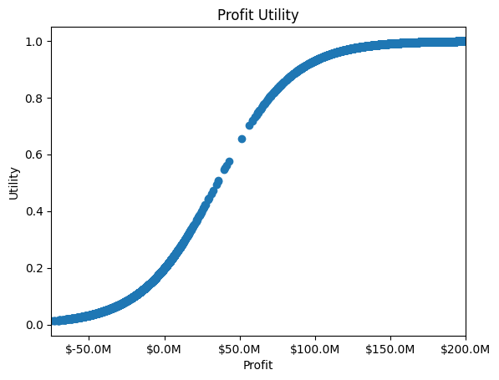

Figure 1: Utility as a function of total profit. Each point represents one possible outcome. There is a sharp increase in utility when going from values of profit that are below the baseline (25M) to those higher than the baseline. Incremental gains in profit generate lower improvements to the utility. The idea is to define the DM’s utility this way so that the model does not take a large risk of losing money for a chance of generating slightly more profit.

Winning Utility. Winning is the secondary objective for the Raptors. The utility of winning a championship is straightforward. If the Raptors win a championship, utility is equal to 1. Otherwise, utility is 0. There is no financial reward associated with winning.

Total Utility. Total utility is represented as follows: U_{T} = (U_{P}, U_{W}), where U_{P} and U_{W} represent profit utility and winning utility, respectively. After holding a workshop with Raptors executives, it was determined that they collectively are indifferent between ($200M, 0) and a lottery where there is a 0.6 probability of the best-case ($200M, 1) and a 0.4 probability of the worst-case (-$120M, 0). They also agreed that they are indifferent between (-$120M, 1) and a lottery where there is a 0.3 probability of ($200M, 1) and a 0.7 probability of (-$120M, 0). The total utility function is as follows:

$U_{T} = k_{1}U_{P}(Profit) + k_{2}U_{W}(Win) +Kk_{1}k_{2}U_{P}(Profit)U_{W}(Win)$,

where k₁ = 0.6, k₂ = 0.18, and K = 2.03. Details on how the parameters were derived can be found in Appendix G.

6 Model results, implications, and limitations

A graphical representation of the complete network model is shown in Figure 2.

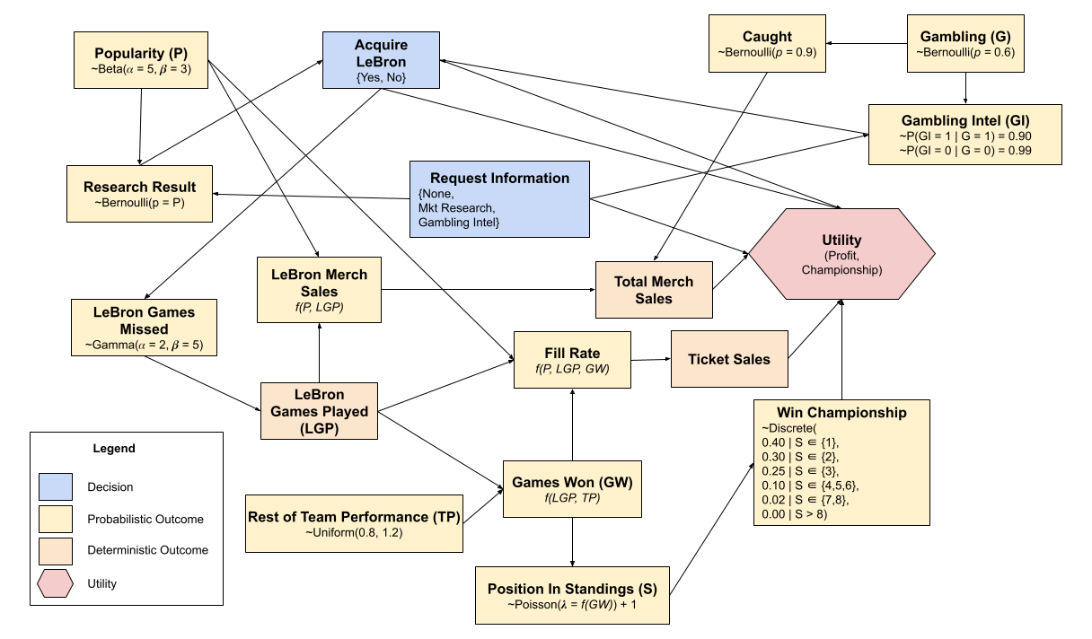
Figure 2: Full Bayesian Network representing the decisions, probabilistic factores, and the final utility.

There are only 6 possible combinations of decisions/outcomes that are logical for the DM to follow, all shown in Table 3. The idea is that either management makes a decision without any research or uses a research method and decides based on it. For instance, it does not make sense for the DM to request a popularity research, get negative results, and still sign LeBron. For each scenario, we then calculate the expected utility using PyMC (see supporting file).

Table 3: All possible logical scenarios. Note that popularity research cannot be conducted with gambling research.

Sign Lebron | Popularity Research | Gambling Research | Popularity Results | Gambling Results | Expected Utility
Yes | No | No | - | - | 0.375
No | No | No | - | - | 0.141
Yes | No | Yes | - | No (Negative) | 0.589
No | No | Yes | - | Yes (Positive) | 0.134
Yes | Yes | No | Yes (High) | - | 0.389
No | Yes | No | No (Low) | - | 0.139

To define the best strategy, however, we need information on the probability of popularity and gambling results of being “Yes”. Still using PyMC, we estimate these probabilities to be 0.625 and 0.520, respectively. With this information, a decision tree was built as shown in Figure 3. Each node has the expected utility as a value, and edges have probabilities as values.

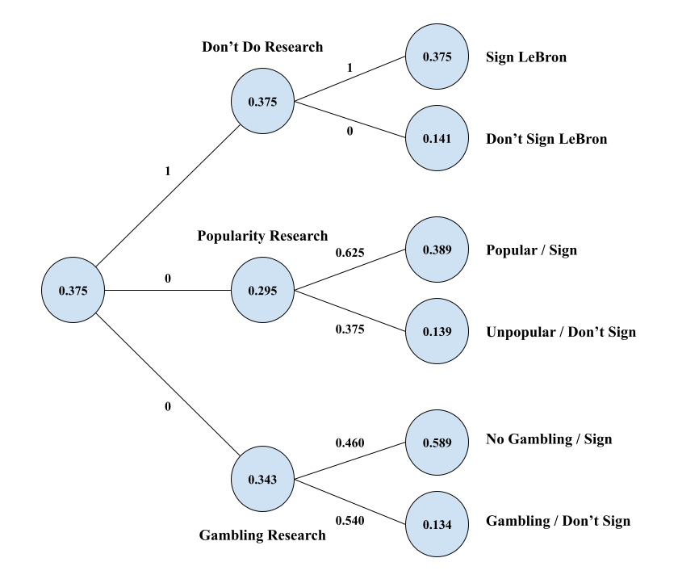
Figure 3: Decision tree representing the possible series of decisions/outcomes that the DM might face. Each node has its expected utility as value, while edges have probabilities as values. In the case of decisions, it is assumed that the DM will choose the one with highest expected utility with probability of 1.

These results imply that acquiring LeBron would be worthwhile for the Raptors under the current set of assumptions made. In fact, it is not recommended that they run market research or get gambling info because even if they follow the recommendation provided by the research, it does not improve the expected utility. Therefore, the decision set is to hire LeBron without collecting any additional information.
This is largely due to the distribution of the collected information. The market research indicator is binary, showing either “high popularity” or “low popularity.” Given this and the binomial nature of the test, results recommend signing LeBron about 62% of the time, based on the average popularity. When popularity hits 0.62, it outputs “low popularity” and advises against signing. Yet, even with popularity below 0.62, signing LeBron can be profitable. For instance, at a popularity level of 0.3 (indicating unpopularity), merchandise sales still exceed his contract cost. The team mainly seeks to avoid extreme unpopularity, a minority case. The key insight is the indicator’s imprecision; it may advise against signing when he should be signed. Thus, the research’s expected utility is low due to its information quality.
Requesting a gambling investigation is also suboptimal. Given the high probability of LeBron gambling, the investigation will advise against signing him 54% of the time. Signing him is a high-risk, high-reward decision. If he is not gambling, utility is 0.589. If caught, his merchandise sales are significantly reduced, resulting in LeBron being a negative asset to the Raptors (financially). Utility drops substantially to 0.09, which is below the expected utility of remaining status quo (0.141). All possible decision sets and associated utilities are shown in Appendix H.
Including championship wins in the utility function encourages signing LeBron regardless of gambling or popularity, as winning is independent of these indicators. The model reflects that only part of utility can be optimized with current information. Signing him benefits both aspects.
- Many of the uncertainties were modeled using subjective probabilities informed by the DM, which implies that the model carries some bias from them.
- Some probability distributions are not 100% realistic or robust. Normal distribution tails are unbounded, and there exists scenarios (although extremely unlikely) where merchandise sales are negative, for example.
- Our model limits the investment on LeBron. However, a more realistic case would be comparing signing him against the best option besides him (maybe bringing Kawhi Leonard back?) to incorporate the idea of opportunity cost.
- Simplifications such as results utility coming only from winning the championship do not necessarily reflect how much fans would be happy. For instance, losing the final in game 7 is definitely better than losing 4-0, which is not considered here.
- Finally, there are thousands of other uncertainties (e.g., are other players going to get injured, is Tim Hortons going to decrease the quality of their coffee and make LeBron mad) that are not modeled and affect the total profits and hence utility.

These limitations do not take the usefulness out of the model. They serve, however, as a warning that the DM should not expect the outcomes to follow exactly what was initially forecasted by the analyst. Overall, the model provides deep, quantifiable insights into the major factors which help in deciding whether to acquire LeBron James.
References

[1] RealGM. (n.d.). Toronto Raptors Playoff History. Retrieved from https://basketball.realgm.com/nba/teams/Toronto-Raptors/28/Playoff-History

[2] Lauton, L. (2023). NBA Injury Stats (1951-2023) [Data set]. Kaggle. Retrieved from https://www.kaggle.com/datasets/loganlauton/nba-injury-stats-1951-2023

[3] NBA.com. (n.d.). NBA Standings: 2023-24 Season. Retrieved from https://www.nba.com/standings?Season=2023-24

[4] Land of Basketball. (n.d.). Champions by Seed. Retrieved from https://www.landofbasketball.com/championships/champions_by_seed.htm

[5] BasketNews. (2023). NBA teams' revenue soaring to $293.83 million via jersey patch partnerships. Retrieved from https://basketnews.com/news-200988-nba-teams-revenue-soaring-to-29383-million-via-jersey-patch-partnerships.html

[6] Grand View Research. (2023). Sports Betting Market Size, Share & Trends Analysis Report By Platform, By Betting Type, By Sports Type, By Region, And Segment Forecasts, 2023–2030. Retrieved from https://www.grandviewresearch.com/industry-analysis/sports-betting-market-report

[7] Lipton, E. (2023, May 13). As Online Gambling Grows, So Does the Financial Toll. The New York Times. Retrieved from https://www.nytimes.com/2023/05/13/sports/online-sports-gambling-regulations.html

[8] Basketball-Reference.com. (n.d.). Toronto Raptors Team Payroll. Retrieved from https://www.basketball-reference.com/contracts/TOR.html

[9] RocketBlocks. (n.d.). Understanding Business Models. Retrieved from https://www.rocketblocks.me/guide/business-model.php

[10] Ticketmaster. (n.d.). Toronto Raptors Tickets. Retrieved from https://www.ticketmaster.ca/toronto-raptors-tickets/artist/806034

[11] WorldMetrics. (n.d.). Most Popular NBA Jerseys. Retrieved from https://worldmetrics.org/most-popular-nba-jerseys/

[12] Statista. (n.d.). Basketball team uniforms wholesale sales in the U.S. from 2007 to 2018. Retrieved from https://www.statista.com/statistics/258734/basketball-team-uniforms-wholesale-sales-in-the-us/

[13] Davidson, N. (2014, August 14). Argos and TFC president leaves MLSE by mutual agreement as Pelley returns. The Globe and Mail. Retrieved from https://www.theglobeandmail.com/sports/article-argos-and-tfc-president-leaves-mlse-by-mutual-agreement-as-pelley/

Appendices

Appendix A: Games Missed Probability Distribution

After collecting real sample data from the NBA database, a histogram was plotted. It is estimated that this sample data best maps to a Gamma distribution with alpha = 2, and beta = 5. An overlay of the histogram and density function is shown below.

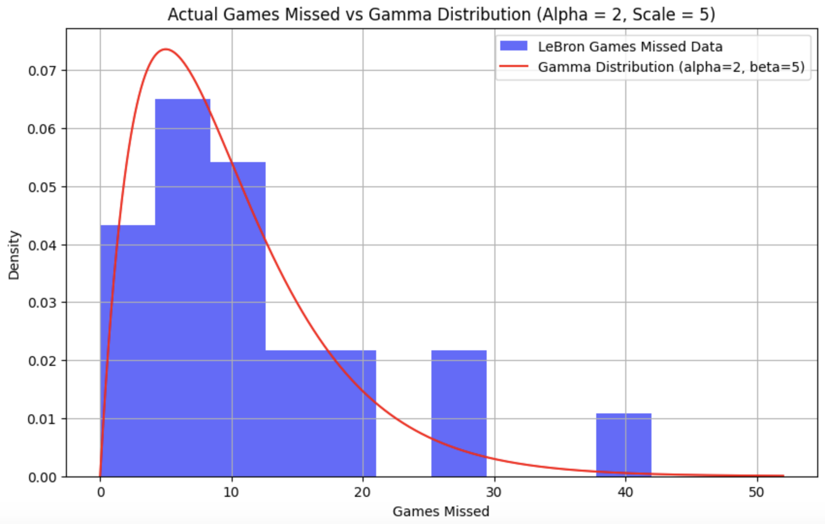

Appendix B: Wins Above Replacement

LeBron’s Wins Above Replacement is 11.5 meaning, over an 82-game season, he is directly responsible for his team winning 11.5 games []. On a per-game basis, his “uplift factor” is 11.5/82 = 0.14.

Appendix C: Position in Standings

The Raptor’s position in the final league standings depends on the number of games won over the 82-game regular season. There is uncertainty around this though, as the performance of other teams has an influence on the final standings. To model this uncertainty, a poisson function is used, with rate parameter 𝜆. This parameter is a function of games won, shown below

$λ= 312e^{-0.11GW}$

The position in standings is equal to ~Poisson(𝜆) + 1. The constant of 1 is added to account for the nature of the Poisson distribution, where outputs begin at 0. There is no “0th place”, so the + 1 allows the values to make sense. As GW increases, 𝜆 decreases, implying a higher expected final position in the standings.

The graph below helps to illustrate the relationship

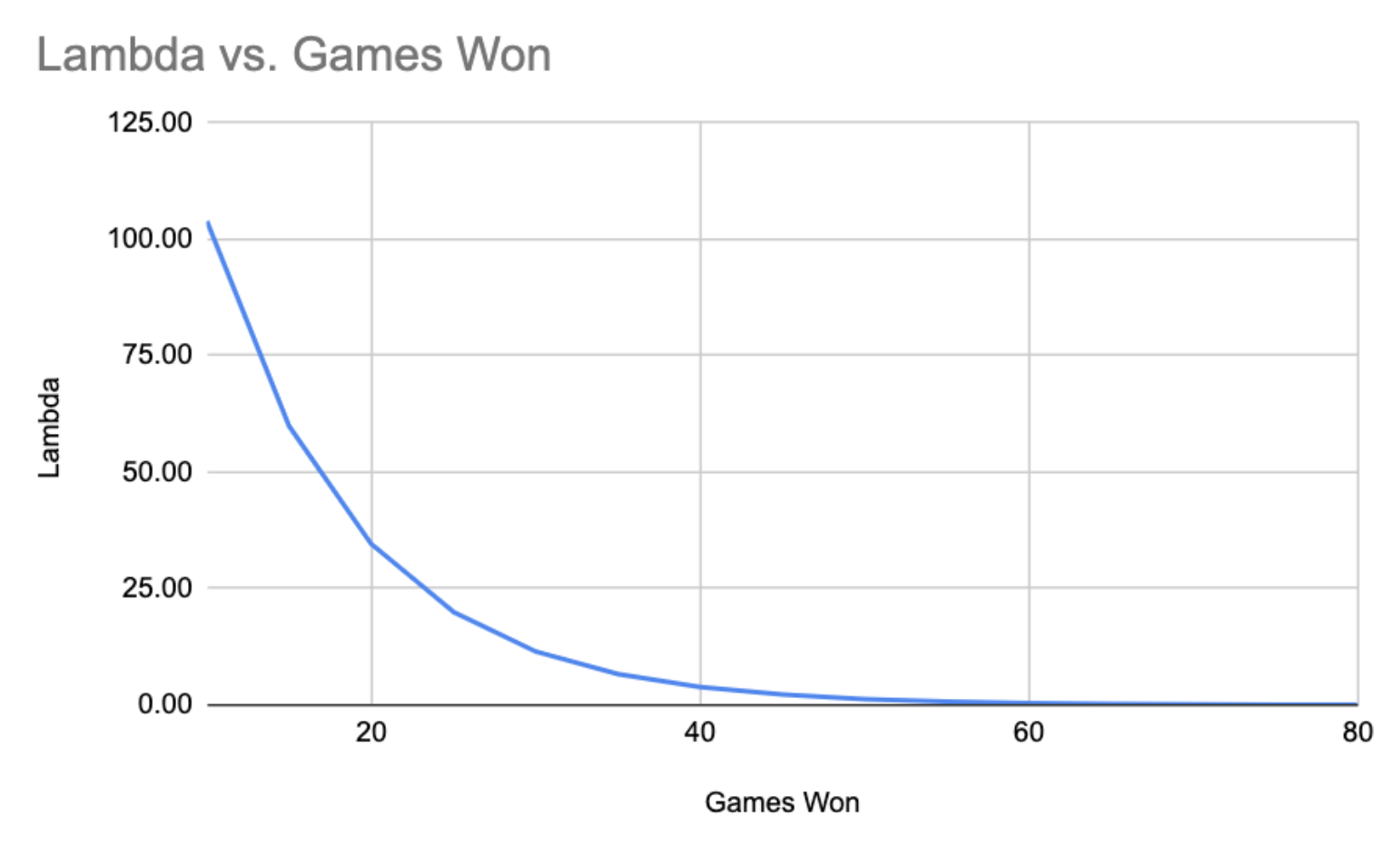

Here are a few illustrations for what the Poisson distribution looks like for different inputs for Games Won.

Example 1: GW = 35, 𝜆 = 6.64. Expected final position in standings is 6.64 + 1 ~ 8th.
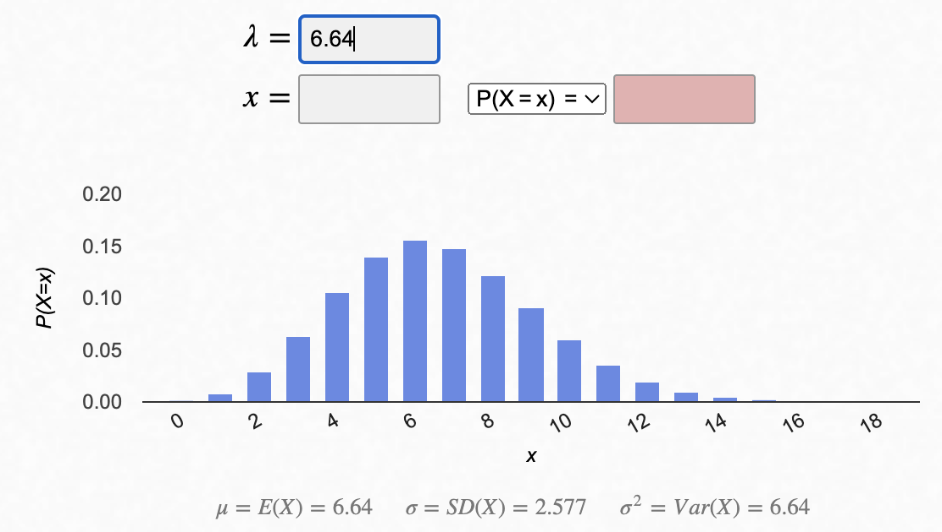

Example 2: GW = 50, 𝜆 = 1.28. Expected final position in standings = 1.28 + 1 ~ 2nd.
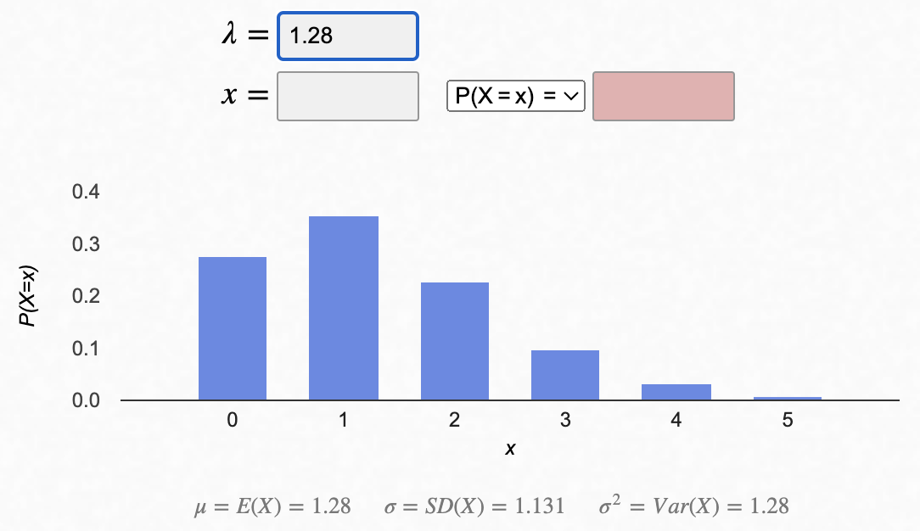

Appendix D: Expected Fill Rate

Ticket sales are directly proportional to the arena’s average fill rate. This is influenced by Games Won (GW), LeBron’s Games Played (LGP), and LeBron’s Popularity (P).

Fill Rate = 0.7 * F_{GW} * F_{LGP} * F_{P}

The 0.7 coefficient represents the baseline fill rate. F_{GW}, F_{LGP}, and F_{P} are scaling factors which themselves are functions of Games Won, Lebron’s Games Played, and LeBron’s Popularity, respectively. Specifically:

$F_{GW} = 1 +( \frac{0.39}{1 + e^{(-0.155(GW - 37.8))}}) - 0.2)$
$F_{LGP} = 1 +( \frac{0.194}{1 + e^{(-0.155(GW - 37.8))}}) - 0.1)$
$F_{P} = 1 +( \frac{0.05}{1 + e^{(-8.61(GW - 0.4))}} - 0.007)$

Games Won has the strongest impact on fill rate. If the team does extremely well, they could see up to a 20% increase in attendance. Conversely, if the team does very poorly, they could see up to a 20% decrease. LeBron’s games played can impact attendance by a factor of 10% below or above expected. Popularity will increase attendance between 0% and 5%.

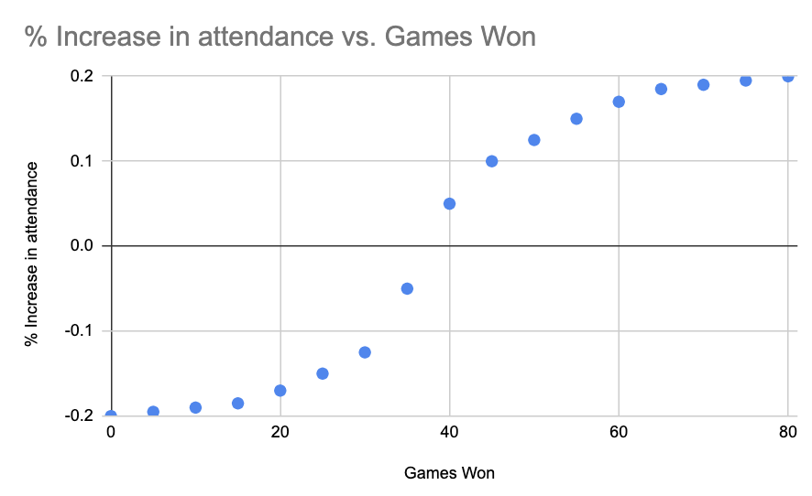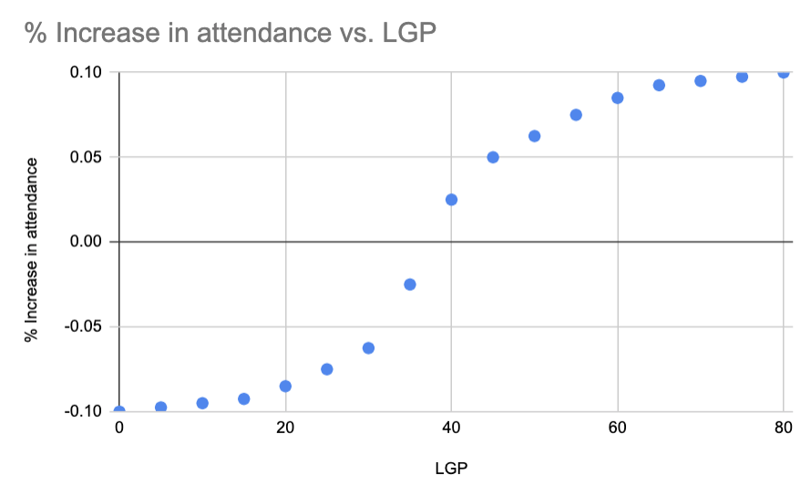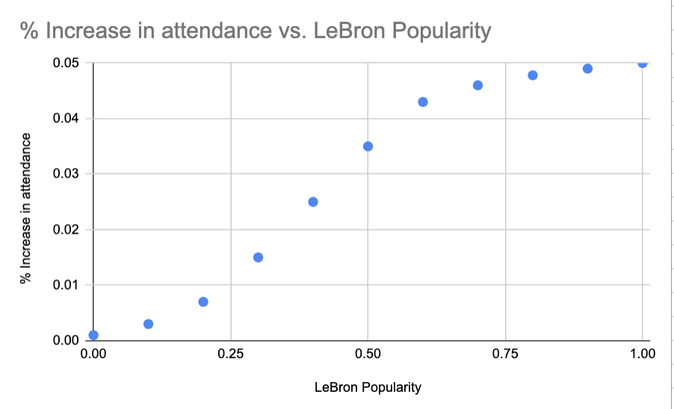

Appendix E: Jersey Sales

The NBA sells 3 different types of jerseys at different price points, depending on their level of authenticity. Research suggests that the most-purchased jersey is the “Mid-Tier” type, followed by the “Budget” and “Top-of-the-line” types. A detailed breakdown of jersey sales and prices is included in the table below.

Jersey Types and Prices
Jersey Type | Price (USD) | Share of Sales
Top of the Line | $135 | 20%
Mid-Tier | $120 | 50%
Budget | $80 | 30%

A weighted average can be used to estimate the average sale price per jersey sold, revealing that the average NBA jersey sells for $111. It is assumed that jersey prices stay constant irrespective of the player name (ie. LeBron James’ jersey costs the same amount as every other NBA player).

By contrast, the volume of jersey sales does differ by player. It is estimated that jersey sale volume follows a Pareto distribution, with alpha = 1.1 and x_min = 1000.
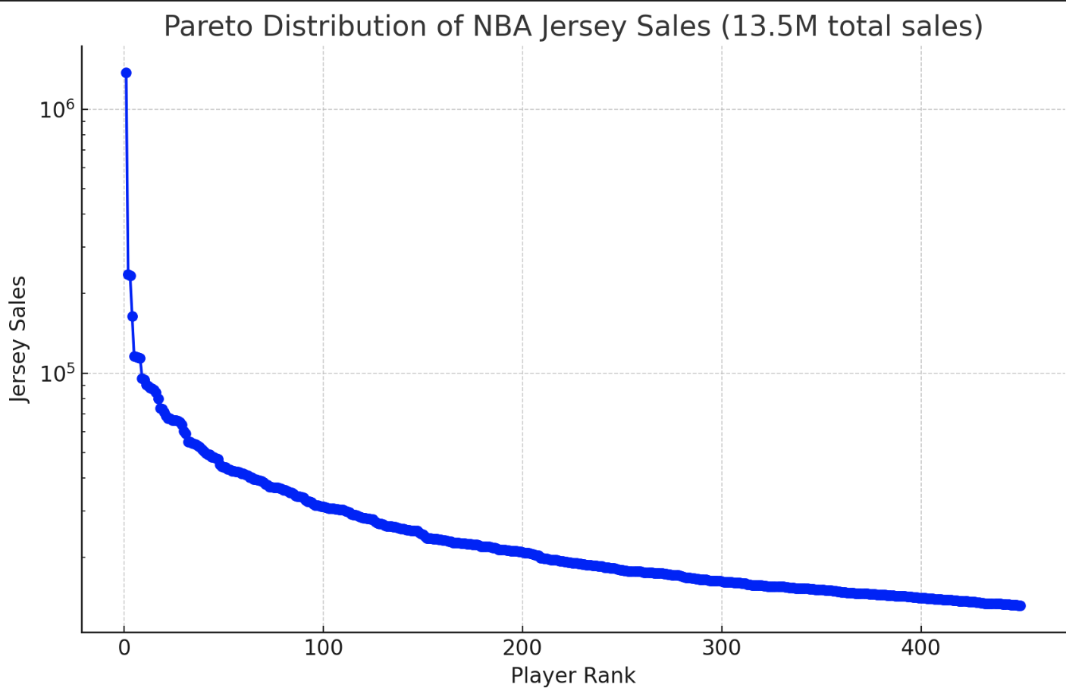

2023 data reveals over $1.5B (USD) was made globally from NBA jersey sales, meaning roughly 13,500,000 jerseys were sold based on the $111 per-unit revenue figure. In 2023, LeBron James had the 3rd-highest selling jersey. While his precise jersey sales are not publicly known, it can be inferred through the Pareto distribution, that 1.2 million LeBron jerseys were sold. This figure will be referred to as “baseline LeBron jerseys sold”. 1.2 Million units sold * $111 per unit provides a baseline LeBron jersey revenue of $133M.

The baseline Raptors jersey sales is assumed to be the equal to the mean NBA jersey sales, multiplied by the total number of players on the roster. The mean NBA jersey sales is informed by the Pareto distribution mentioned earlier, which is equal to 11,000 jerseys sold per player per year. Thus, existing total Raptors jersey sales =

11,000 (units sold per player) * 15 (players on roster) * ($111 dollars per unit) = $18.3 M

Appendix F Other Financial Line Items

Raptors additional financial information, beyond the items discussed in detail

 | Item | Amount (USD)
Revenues | Corporate Sponsorships | $20 M
Revenues | Broadcast Deals | $10 M
Costs | Overhead | $5 M
NET ADDITIONAL PROFIT |  | $25 M

Appendix G: Deriving Total Utility

Total utility is based on 2 objectives: profit and winning a championship. According to MLSE executives, profit is the primary (most heavily weighted) objective, followed by winning. This is due to extreme financial pressures. Total utility is represented as follows: U_{T} = (U_{P}, U_{W}), where U_{P} and U_{W} represent profit utility and winning utility, respectively. From direct interviews with top executives, the following lottery indifferences were elicited:

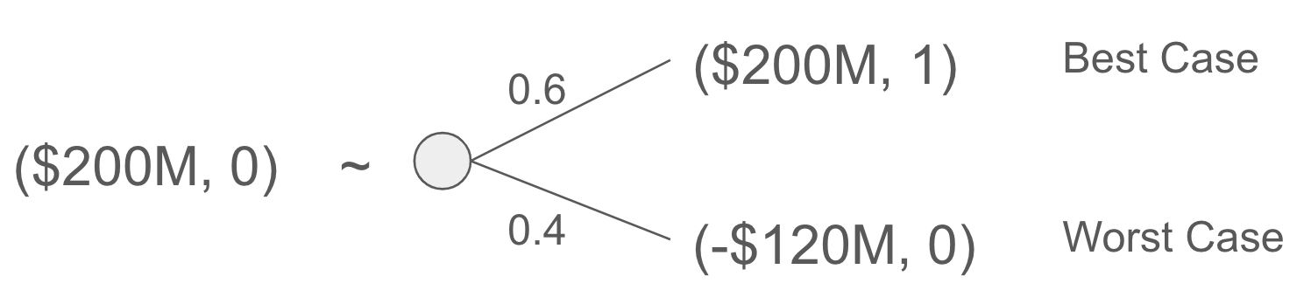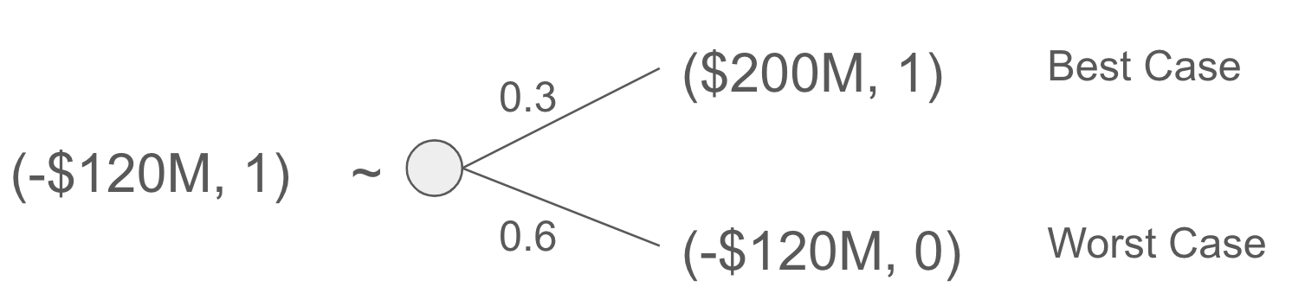
Fig 1 Fig 2

From Fig 1, k₁ = 0.7. From Fig 2, 𝛼 = 0.3. This means that k₂ = 𝛼k₁ = 0.6*0.3 = 0.18.
We know that 1 + K = $\prod_{i = 1}^{2}{}(1 + Kk_{i})$.
Solving for K, we get K = 2.03.

Appendix H: Decision Sets and Corresponding Expected Utilities

Strategy | Expected Total Utility
Status quo. No acquisition, no research. | 0.134
Acquire LeBron, no research | 0.368
Collect gambling intel, follow advice | 0.389
Collect gambling intel, results suggest he is gambling, do not acquire LeBron | 0.141
Get gambling intel, result suggests he is not gambling, acquire LeBron | 0.589
Get gambling intel, result suggests he is gambling, acquire LeBron anyway | 0.098
Collect market research data, result suggests high popularity. Acquire LeBron | 0.374
Collect market research data, result suggests low popularity. Acquire LeBron anyway | 0.304
Collect market research data, result suggests low popularity, do not acquire LeBron | 0.139

